To run the application, unzip the file and execute the jar file:



Once the application starts, it will send an initial prompt message to the "To" phone number, either specified in the program itself, or saved as a user environment variable in a file such as .bashrc. The console will output the Flow ID, letting you know that the Twilio Flow has been initiated and an initial prompt message should be on its way to your phone:



The initial prompt will ask you submit one of four choices: ADD, GET, DELETE, or UPDATE. Type in and enter one of these choices to proceed. If you enter something other than the above four, you will get a message warning you of an invalid response, and it will prompt you again. You can perform any of these actions in any order.

If you choose ADD, another message will ask you for the appointment details. Anything will work, but the desired format is xx/xx/xx xx:xx/am/pm. For example, enter 12/16/2018 2:15pm and press enter on your phone. You will get a message saying your request processed successfully. Your appointment can be viewed in the mysql database:

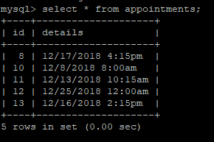

The initial prompt asking you to pick one of the four choices will be sent to your phone again.

Choose GET to get the details of an appointment in the database. A message asking for an id will appear, and upon entering the id you will receive a message with that appointment's details.

The initial prompt asking you to pick one of the four choices will be sent to your phone again.

Choose DELETE to delete an appointment in the database. A message asking for an id will appear, and upon entering the id you will receive a message saying that your appointment has been deleted.

The initial prompt asking you to pick one of the four choices will be sent to your phone again.

Choose UPDATE to update an existing appointment in the database. A message asking for an id will appear, and upon entering the id you will receive a message saying that your appointment has been updated.

The initial prompt will appear again, and you can perform any of these actions again indefinitely.

The logic behind this is managed by Twilio's Flow feature. The following is a screen shot of the flow:

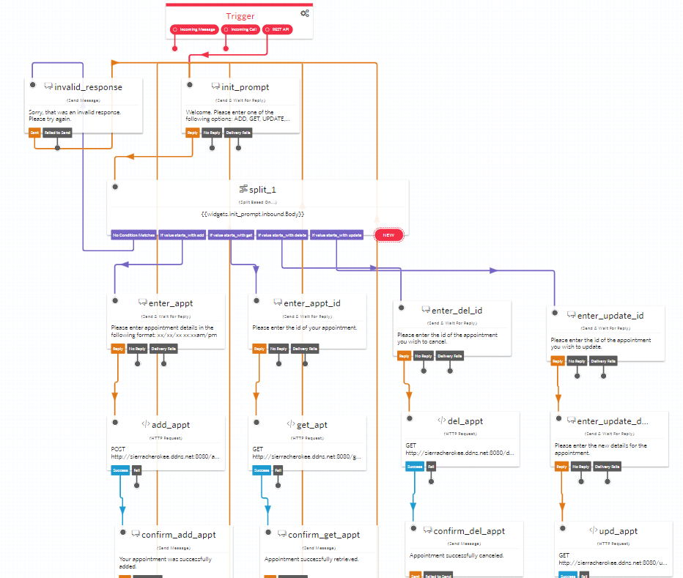

The four REST methods each have Execution Log and Time aspects that will print on the console when executed as well the Hibernate statement saying an operation was performed on the database.

/addAppointment:

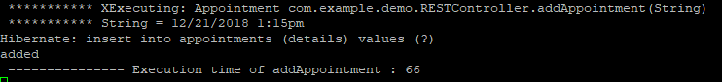

/getAppointment:

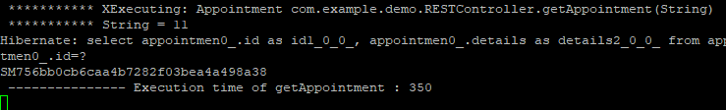

/deleteAppointment:

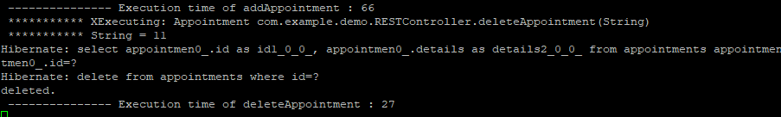

/updateAppointment:

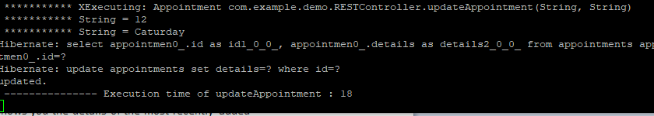

Periodically, you will receive two messages.

One is a reminder message that shows you the details of the most recently added appointment. The console will output the Execution Log and Time of the method, the details of the appointment, and the Twilio message ID confirming that the message was sent to your phone:

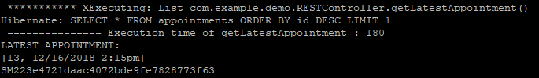

The other is a message counting down the days until Christmas Day, and attached is a festive gif. The console will output the message "There are x days until Christmas.", and the Twilio message ID confirming that the message was sent to your phone:

